The Jo Regenold Fund

Arizona State Application

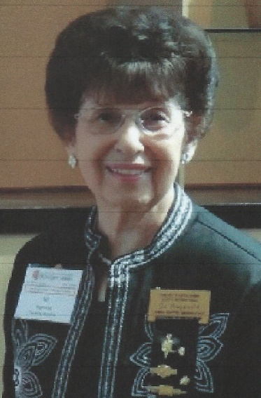

The purpose of this fund is to provide small financial opportunities for active Delta Kappa Gamma educators who encounter extra expenses as a result of their jobs in education.

Potential uses are as follow:

~student-enriching project such as science, art, music

~production of a dramatic performance

~field trip not covered by employer

~conference or seminar registration, supplies

In other words, this fund is intended to help educators defray out-of-pocket expenses. They might be incurred as a result of a classroom project to enrich student learning or outside studies that serve to enhance the teacher’s abilities to increase student learning.

The DKG AZ Scholarship Committee is responsible for receiving and reviewing applications. The allocated funds will then be promptly awarded. This will not be tied to a convention’s timing but will be reported in the committee’s business report given at the conventions.

Applications may be submitted any time August through April 1 of a given year. Submit applications to the DKG AZ Scholarship chair for review by the committee:

Sandy Hillegass

Cell: 602 769 2121

Home (602) 938-0277

[shill4570@aol.com](mailto:shill4570@aol.com)

**Jo Regenold Fund Application**

Name_____________________________________ Date________

DKG Chapter______________________________________________

Membership Number________________________________________

Address__________________________________________________

________________________________________________________

________________________________________________________

Phone number_____________________________________________

Email Address_____________________________________________

**Please address the following questions and email it to the DKG AZ Scholarship chairman.**

**1. What activity are you proposing?**

**______________________________________________________________________________________________________________________________________________________________________________________________________________________________________________________________________________________________________________________________________________________________________________________________________________________________________________________________________________________________________________________________________________________________________________________________________________________________________________________**

**2. What are the goals or specific outcomes you desire when the activity is completed?**

**_____________________________________________________________________________________________________________________________________________________________________________________________________________________________________________________________________________________________________________________________________________________________________________________________________________________________________________________________________________________________________________________________________________________________________________________________________________________________________________________**

**3. How do you propose to spend the money?**

**_______________________________________________________________________________________________________________________________________________________________________________________________________________________________________________________________________________________________________________________________________________________________________________________________________________________________________________________________________________________________________________________________________________________________________________________**

**4. How will you evaluate the activity to see how well it has achieved its goals or outcomes?**

**____________________________________________________________________________________________________________________________________________________________________________________________________________________________________________________________________________________________________________________________________________________________________________________________________________________________________________________________________________________________________________________________________________________________________________________________________________________________________________________________________________________________________________________**



**5. A final report to the Scholarship Committee will be due at the end of the project or by the end of the school year, whichever comes first.**

DKG AZ Organization

Scholarship Committee Chairman

Sandy Hillegass

Home: 602 938-0277

Cell: 602 769 2121

Email:  [shill4570@aol.com](mailto:shill4570@aol.com)

Revised Aug 2021