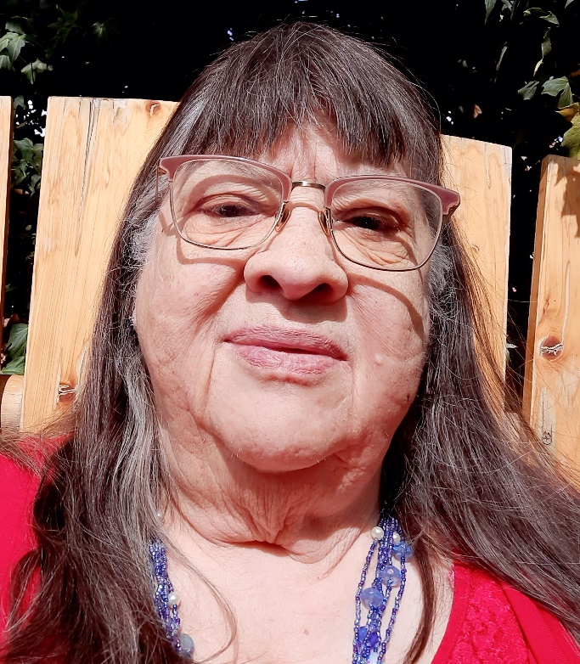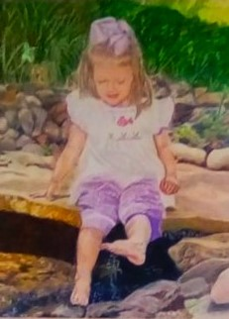
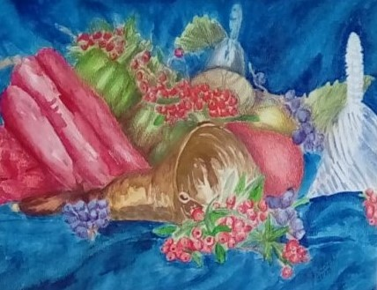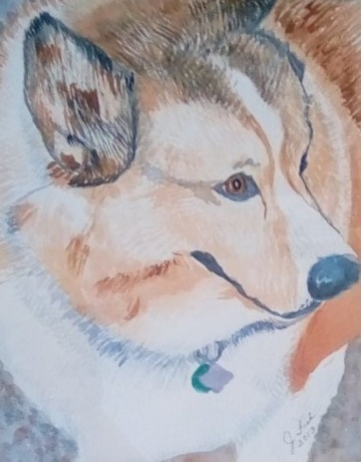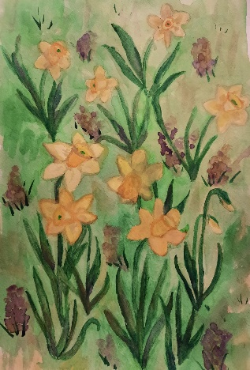

I am so honored to be chosen to appear on this page. Although I have always been a hands-on person, but I always considered myself hopeless in drawing and painting. I have done lots of needlework, quilting, flower arranging, jewelry making, paper crafts and so on, but no drawing or painting. I promised myself that when I retired, I was going to give it a serious try. The fall after I retired, I enrolled at community college and am probably the oldest and the longest attending art student they have ever had. I love to try new things and keep experimenting in new media and styles. Since the best of my recent work can be seen in the DKG online gallery archives, I’ve decided to include 3 of my all-time favorite works here, even though they are a little older. Anna is done in colored pencil and the other two are watercolors. My dream of being a lifetime learner is coming true every day.

